Exercise 5

Write a Java program that meets the following requirements.

1. Class name is Exercise5
2. File name is Exercise5.java
3. The program should declare a main method.
   1. In the main method the program should implement the logic of the given activity diagram.

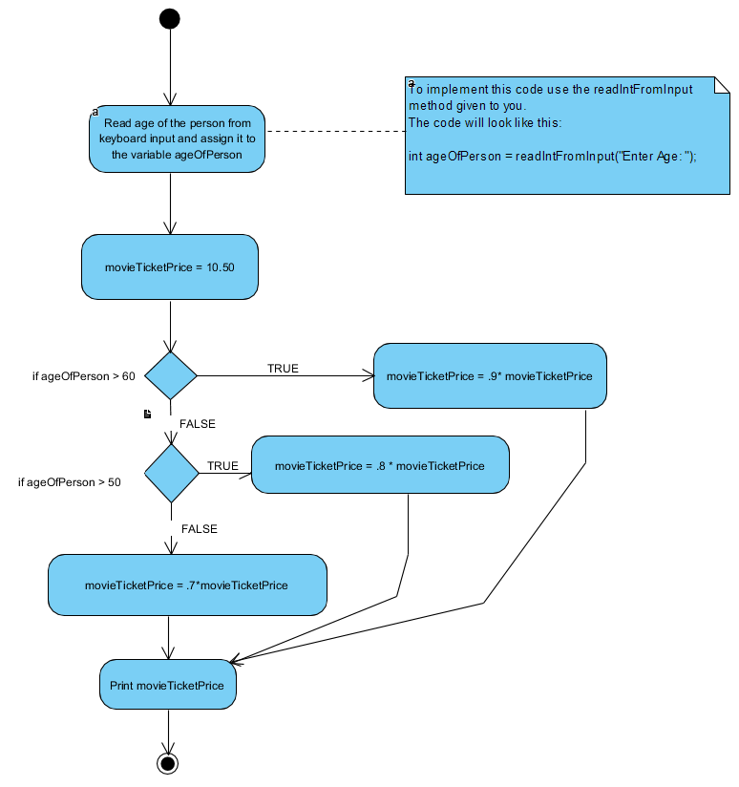

1. NOTES:
   1. Compile your code with the command: javac Exercise5.java
   2. Execute your code with the command: java Exercise5
   3. Your code should prompt the user for an age. The code will not continue until the user enters an age and hits enter.

Test your code with entering multiple values of age. For example, the output of your code might be:

Enter Age: 30

Movie Ticket Price is 7.35

Enter Age: 55

Movie Ticket Price is 8.400001

Enter Age: 72

Movie Ticket Price is 9.45

Use this code below as a framework for Exercise 5, i.e. copy this code below to get you stared.

**import** java.util.Scanner;

**public** **class** Exercise5 {

**public** **static** **int** readIntFromInput(String prompt) {

System.***out***.print(prompt);

Scanner sc = **new** Scanner(System.***in***);

**int** value = sc.nextInt();

sc.close();

**return** value;

}

**public** **static** **void** main(String[] args) {

//giving you first part

**int** ageOfPerson = *readIntFromInput*("Enter Age: ");

//your code for Exercise 5 goes here...

}

}